**Calibration for Venturi-meter**

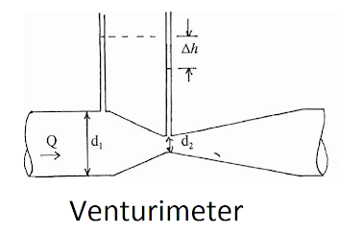The main objectives of this experiment is to obtain the coefficient of discharge from experimental data by utilizing Venturi meter, Understand the effect of decrease in area on the velocity and pressure of the flowing fluid and Understand the relationship between velocity and pressure of flowing fluid.

**Theory:**

Applying Bernoulli’s equation at 2 sections

$\frac{P_{1}}{w}+\frac{{V_{1}}^{2}}{2g}+Z_{1}=\frac{P_{2}}{w}+\frac{{V_{2}}^{2}}{2g}+Z_{2}$

Since Z1=Z2

Therefore

H= $\frac{{V_{1}}^{2}}{2g}$ + h constant at all sections

Q=AV

🡪

🡪

🡪

**Tables and Calculations:**

|  |  |  |  |  |  |
| --- | --- | --- | --- | --- | --- |
| N | V1(liter) | V2(liter) | t | H1(mm) | H2(mm) |
| 1 | 1 | 3 | 21.6 | 180 | 75 |
| 2 | 1 | 3 | 20 | 145 | 30 |
| 3 | 1 | 3 | 19 | 150 | 10 |
| 4 | 1 | 3 | 14.2 | 220 | 20 |

A1= $\frac{π}{4}×{25}^{2}=$ 490.87 ${mm}^{2}×{10}^{-4}=0.00049087m^{2}$

A2= $\frac{π}{4}×{10}^{2}=78.54 {mm}^{2}×{10}^{-4}=0.00007854m^{2}$

For 1:- $Q_{th}=\frac{0.00049087 ×0.00007854}{\sqrt{{0.00049087}^{2}-{0.00007854}^{2}}}×\sqrt{2×9.8×(180-75)×{10}^{-3}}=1.14×{10}^{-4}$

$$Q_{actual}=\frac{3-1}{21.6}=0.92×{10}^{-4}$$

$$C_{d}=\frac{0.92}{1.14}=0.807$$

|  |  |  |  |
| --- | --- | --- | --- |
| N | $$Q_{actual}(\frac{m^{3}}{s})$$ | $$Q_{th}(\frac{m^{3}}{s})$$ | $$C_{d}$$ |
| 1 | $$0.92×{10}^{-4}$$ | $$1.14×{10}^{-4}$$ | 0.807 |
| 2 | 1 $×{10}^{-4}$ | 1.195 $×{10}^{-4}$ | 0.836 |
| 3 | 1.053 $×{10}^{-4}$ | 1.31 $×{10}^{-4}$ | 0.804 |
| 4 | 1.408 $×{10}^{-4}$ | 1.57 $×{10}^{-4}$ | 0.893 |

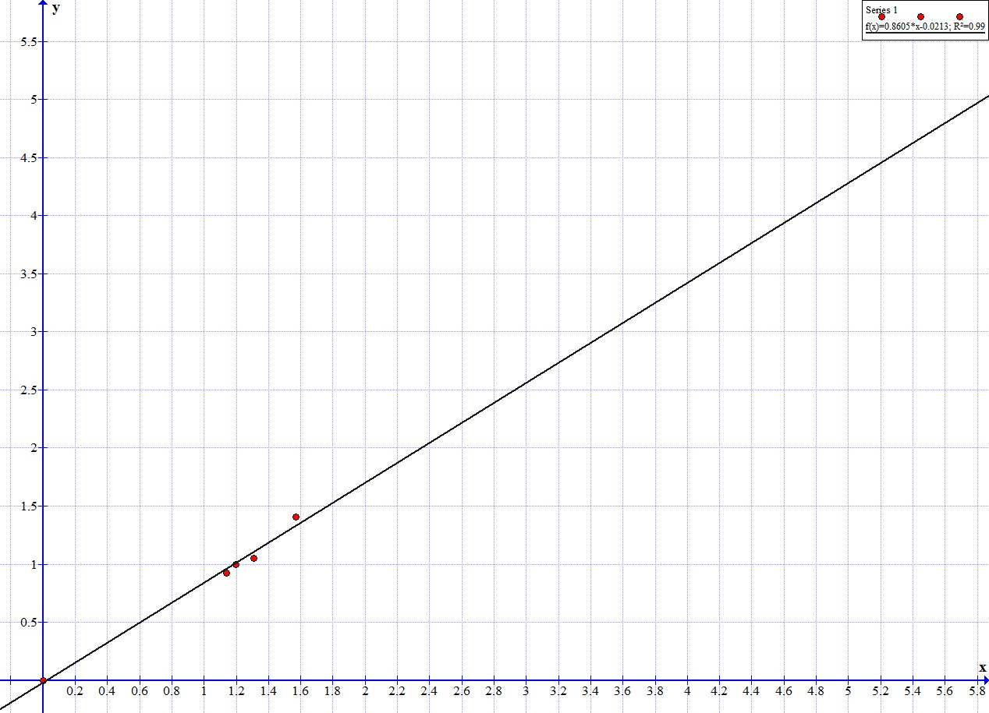Qact vs Qth

**Conclusion:**

 it can be seen clearly that a rise in differential head of two tubes causes the flow rate of the liquid in the tubes to increase and this proves the Venturi effect.